Policies_Verifying Agency Billed Policy_Instance43_29-May-2018_04-43-37_AM_MouseClickActiononStaleElement.png

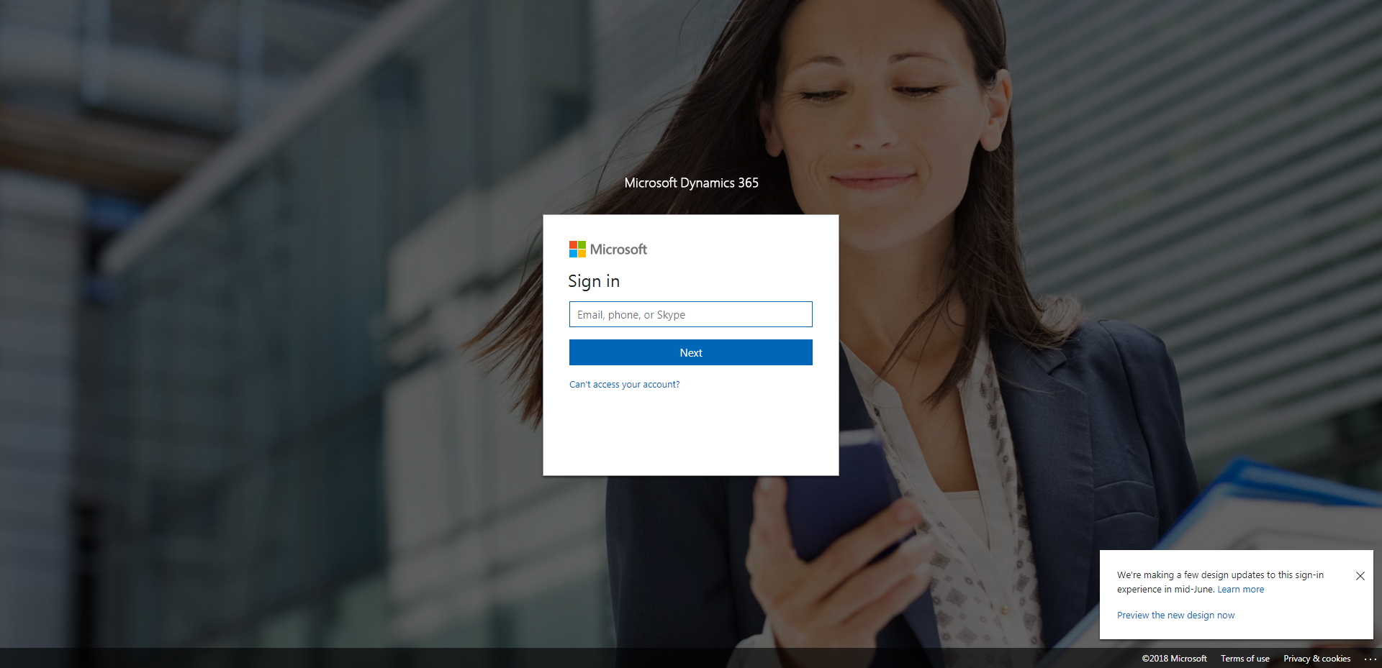

Policies_Verifying Agency Billed Policy_Instance43_29-May-2018_04-44-11_AM_SingleSignOn.png

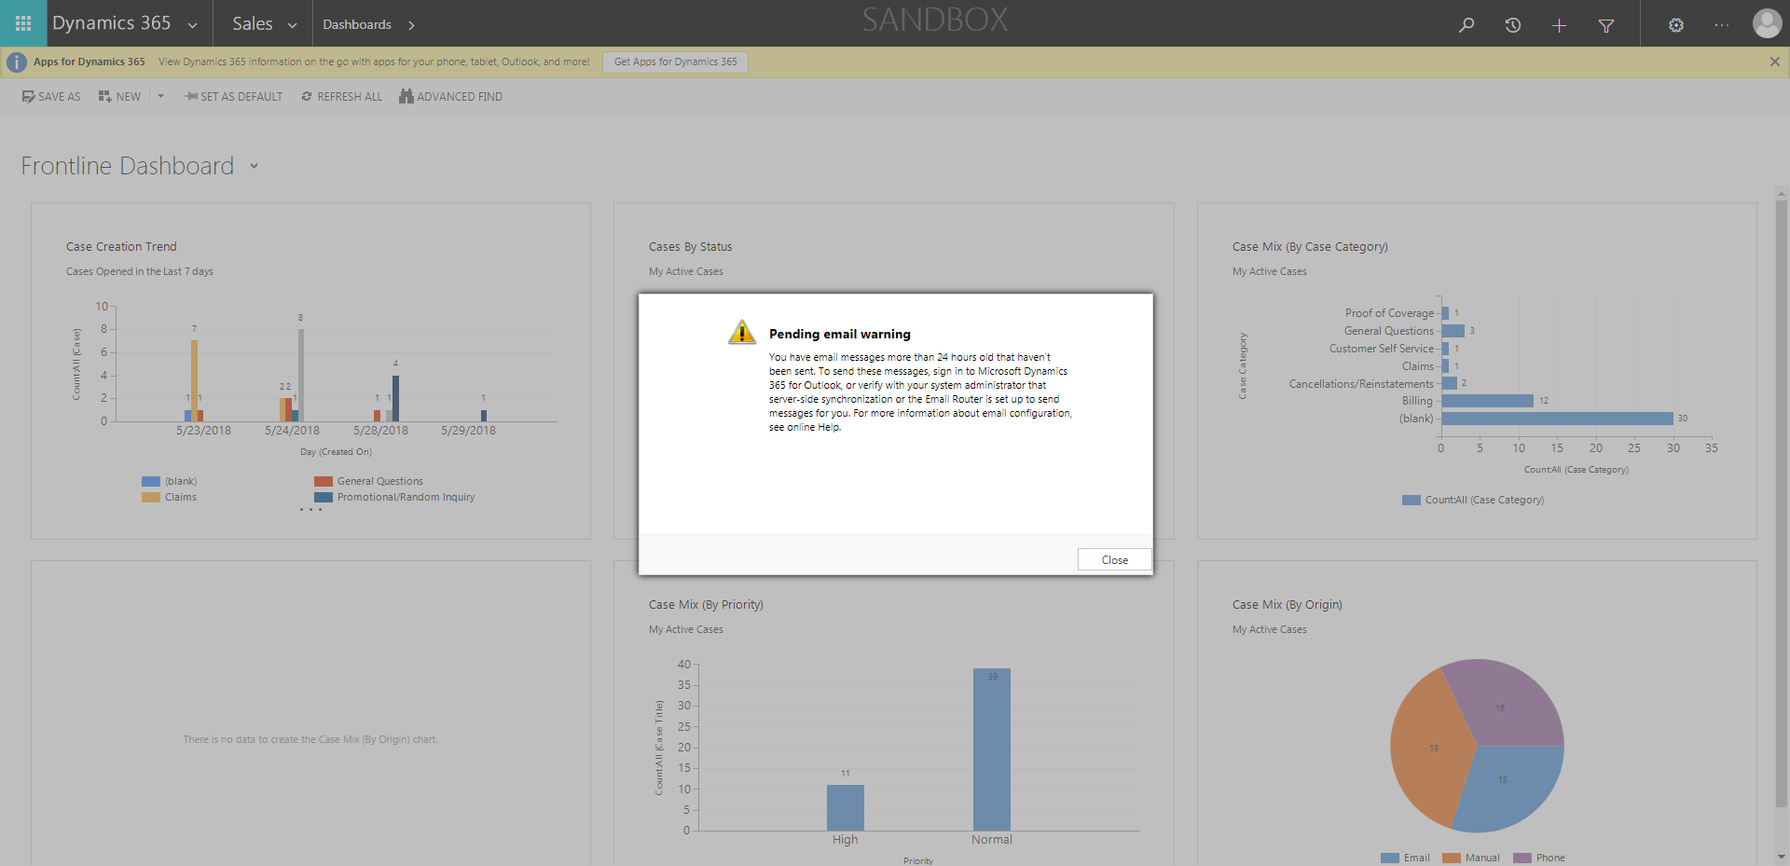

Policies_Verifying Agency Billed Policy_Instance43_29-May-2018_04-43-41_AM_MouseClickActiononStaleElement.png

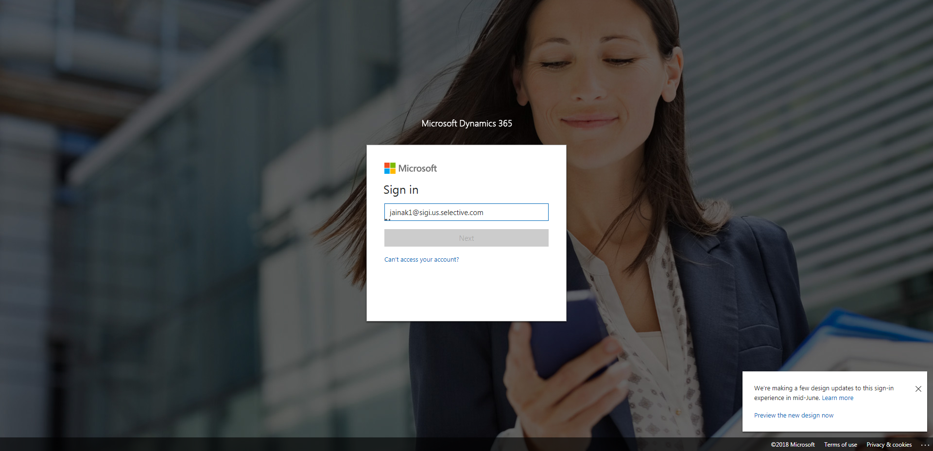

Policies_Verifying Agency Billed Policy_Instance43_29-May-2018_04-44-39_AM_ValidationofAgencyBilledPolicy.png

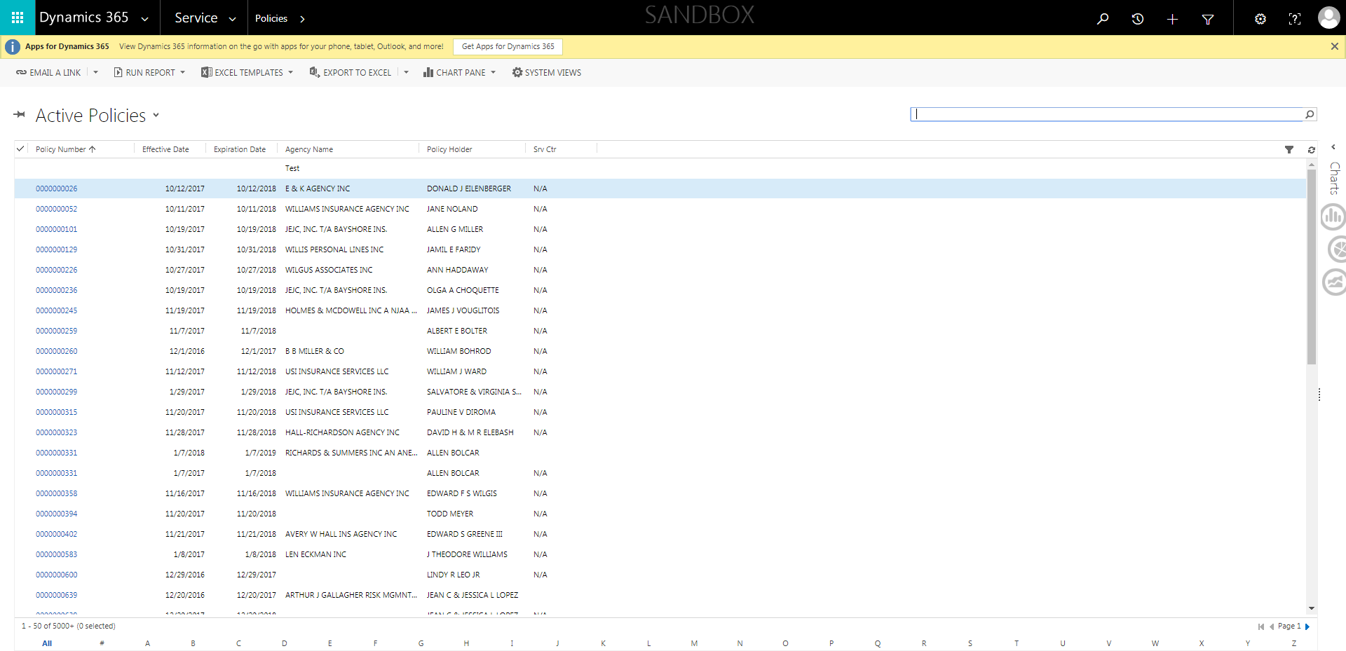

Policies_Verifying Agency Billed Policy_Instance43_29-May-2018_04-44-17_AM_SingleSignOn.png

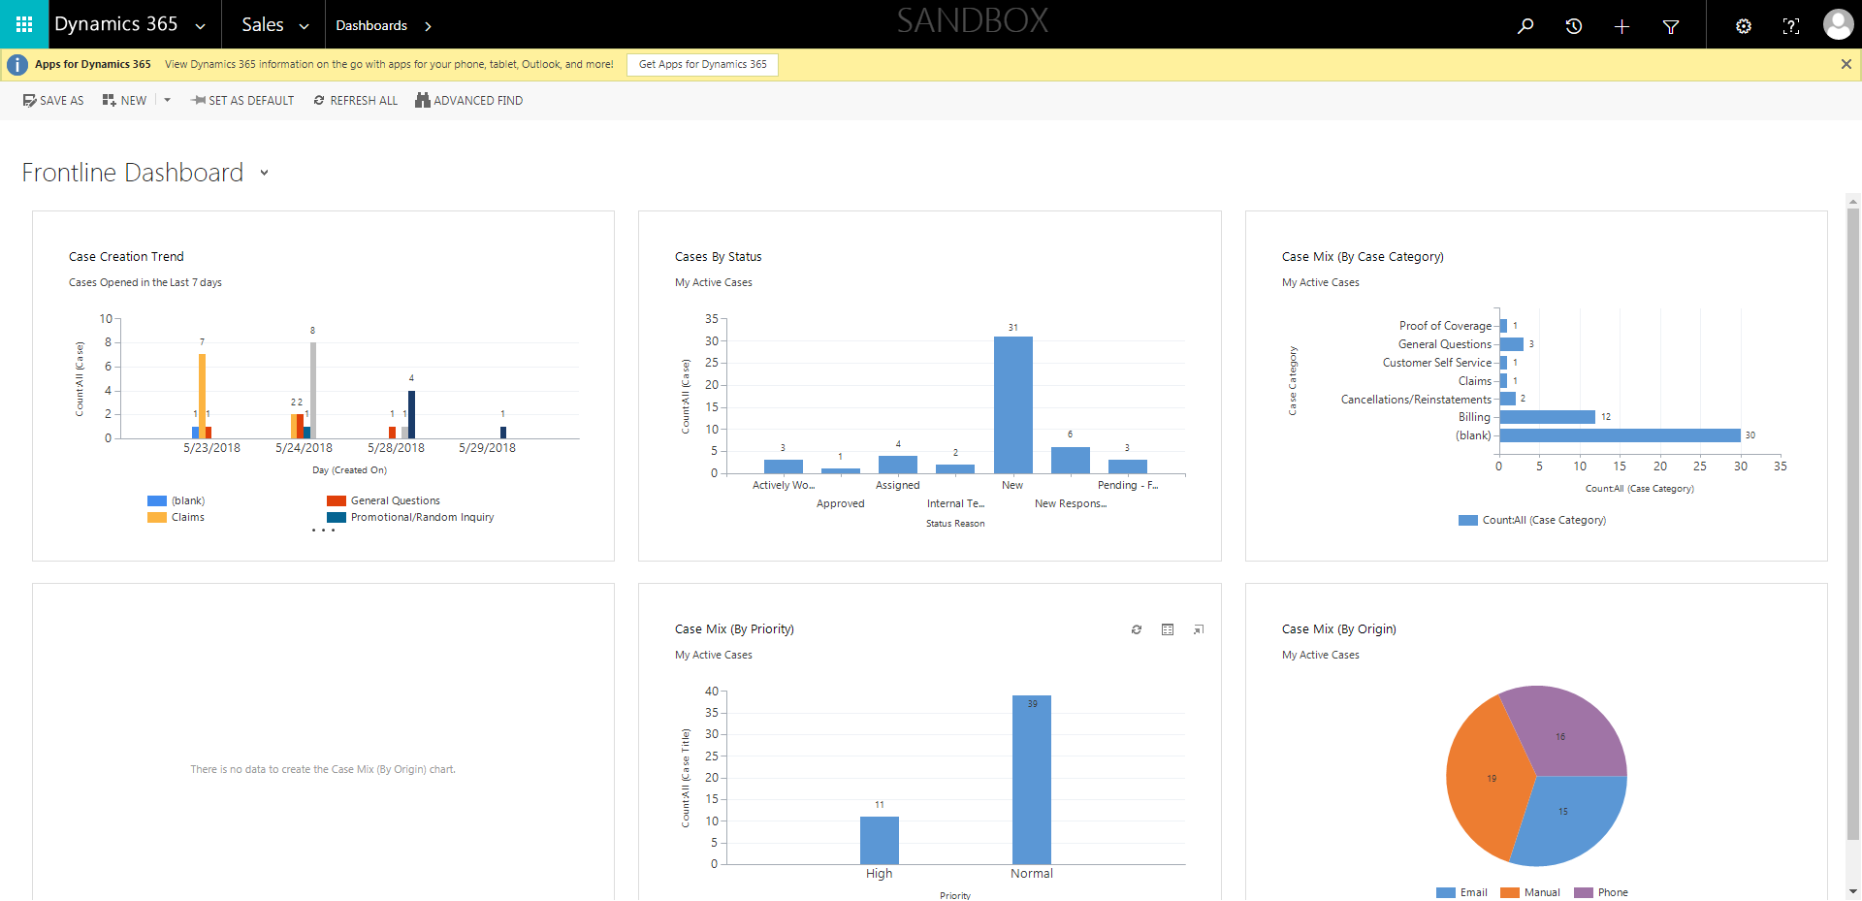

Policies_Verifying Agency Billed Policy_Instance43_29-May-2018_04-43-39_AM_EnterTextAction.png

